Pre- step to do for kernel upgrade.

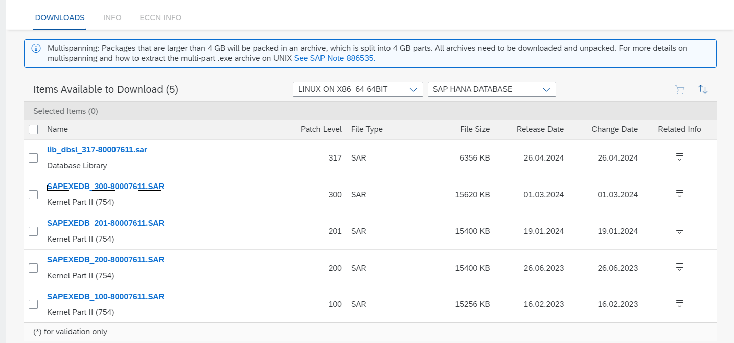

**[SAPEXEDB_300-80007611.SAR](https://launchpad.support.sap.com/?sap-ui-language=en-US&sap-ui-theme=sap_fiori_3&help-theme=horizon)** – SAP hana database

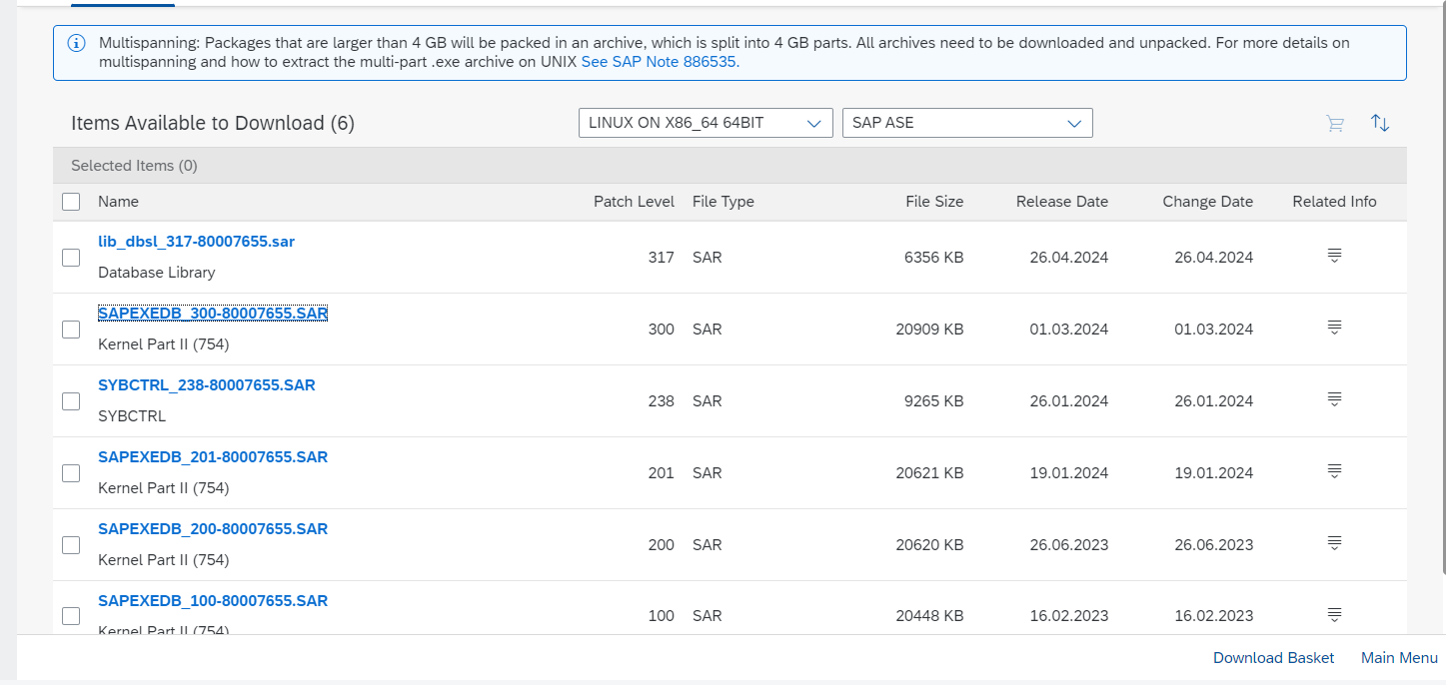

**[SAPEXEDB_300-80007655.SAR](https://launchpad.support.sap.com/?sap-ui-language=en-US&sap-ui-theme=sap_fiori_3&help-theme=horizon)** – sap ASE

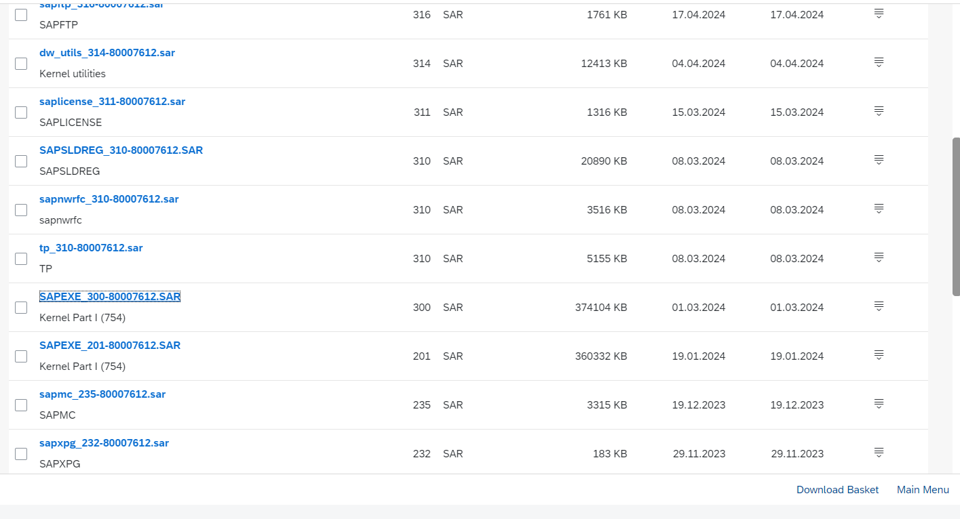

**[SAPEXE_300-80007612.SAR](https://launchpad.support.sap.com/?sap-ui-language=en-US&sap-ui-theme=sap_fiori_3&help-theme=horizon)** - DB independent

Web dispatcher

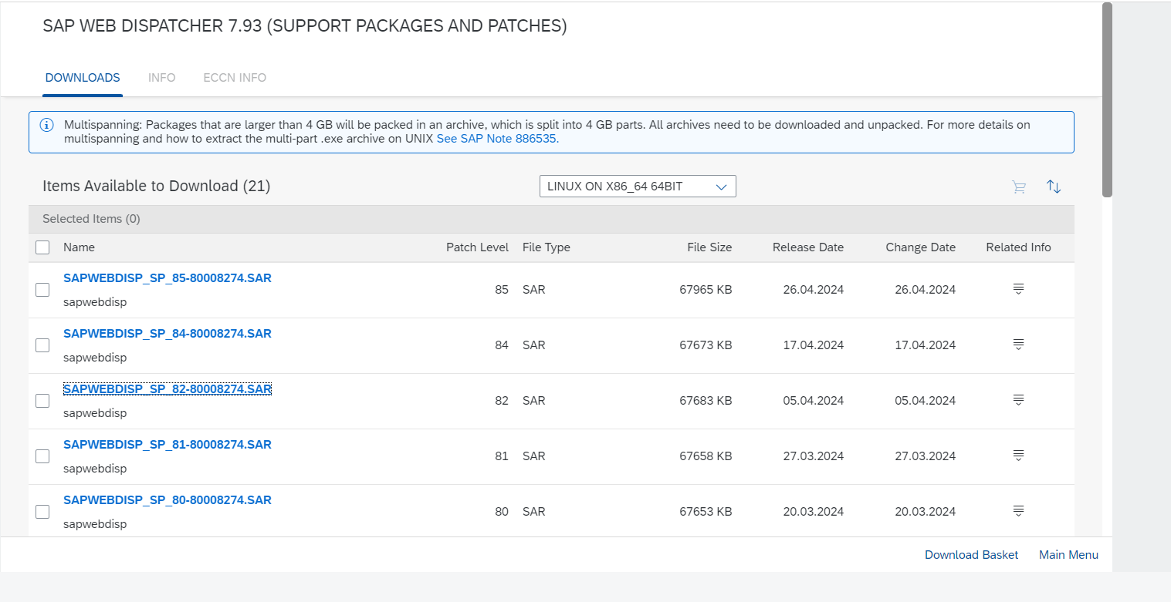

[**SAPWEBDISP_SP_82-80008274.SAR**](https://launchpad.support.sap.com/?sap-ui-language=en-US&sap-ui-theme=sap_fiori_3&help-theme=horizon) – web dispatcher.

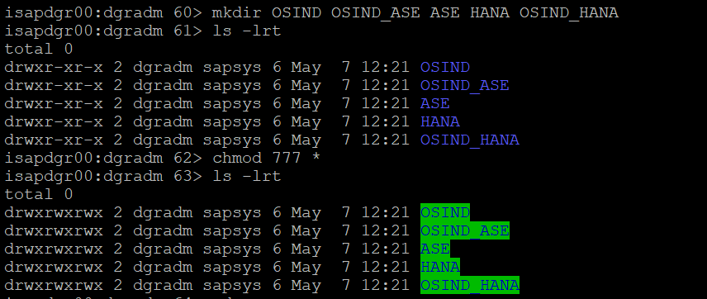

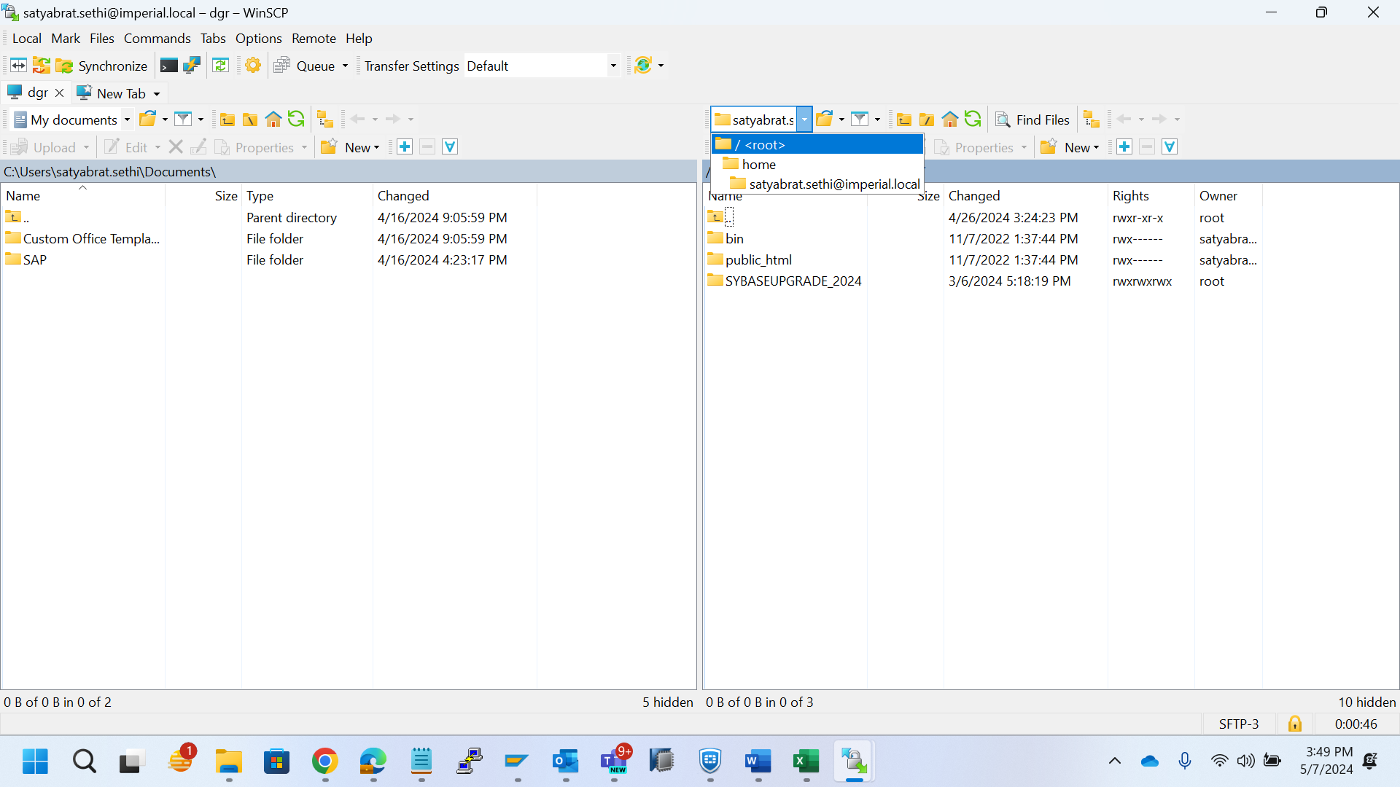

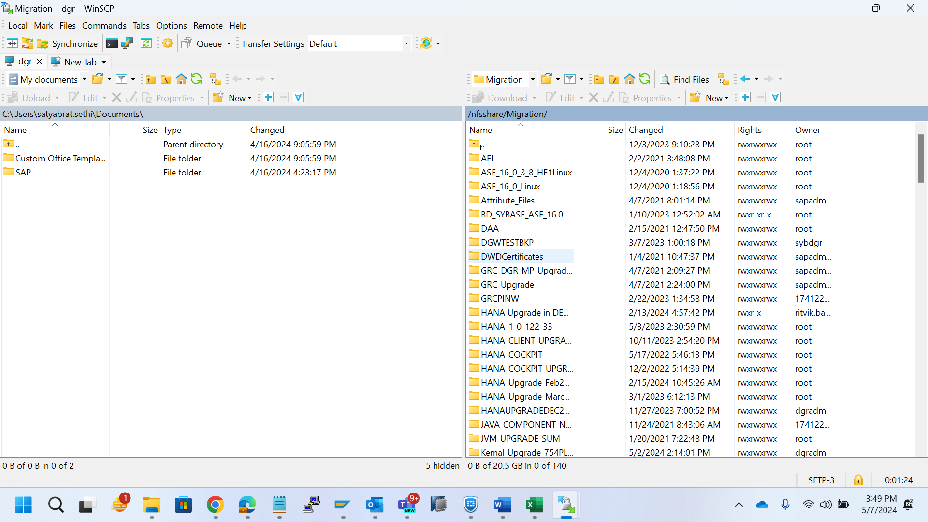

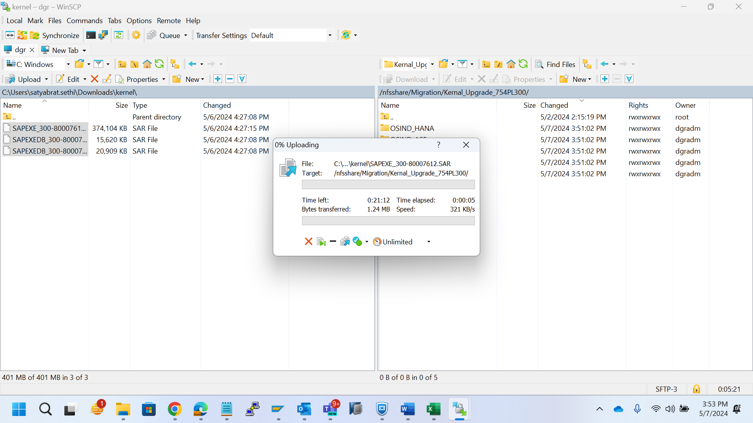

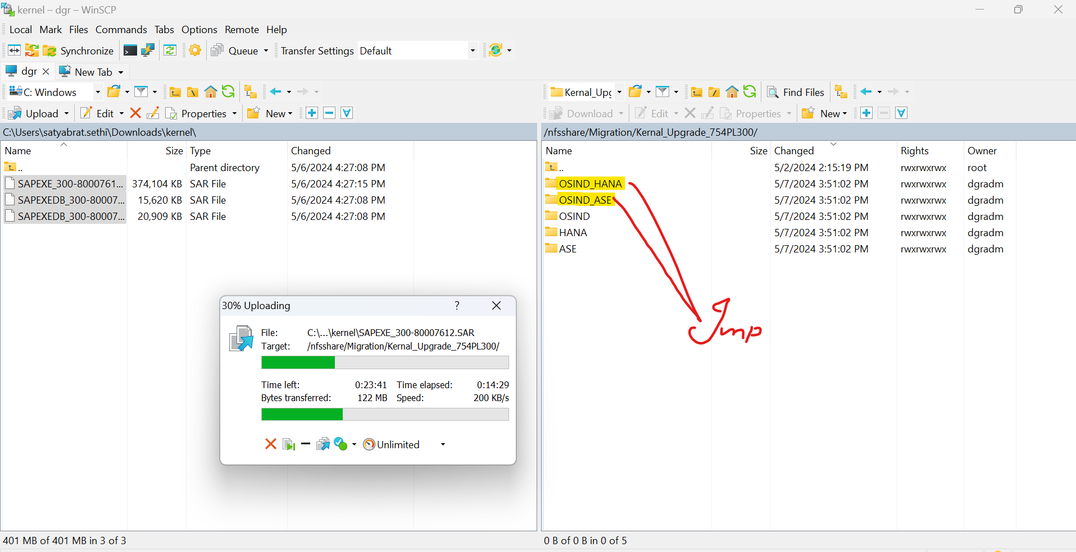

Backup –

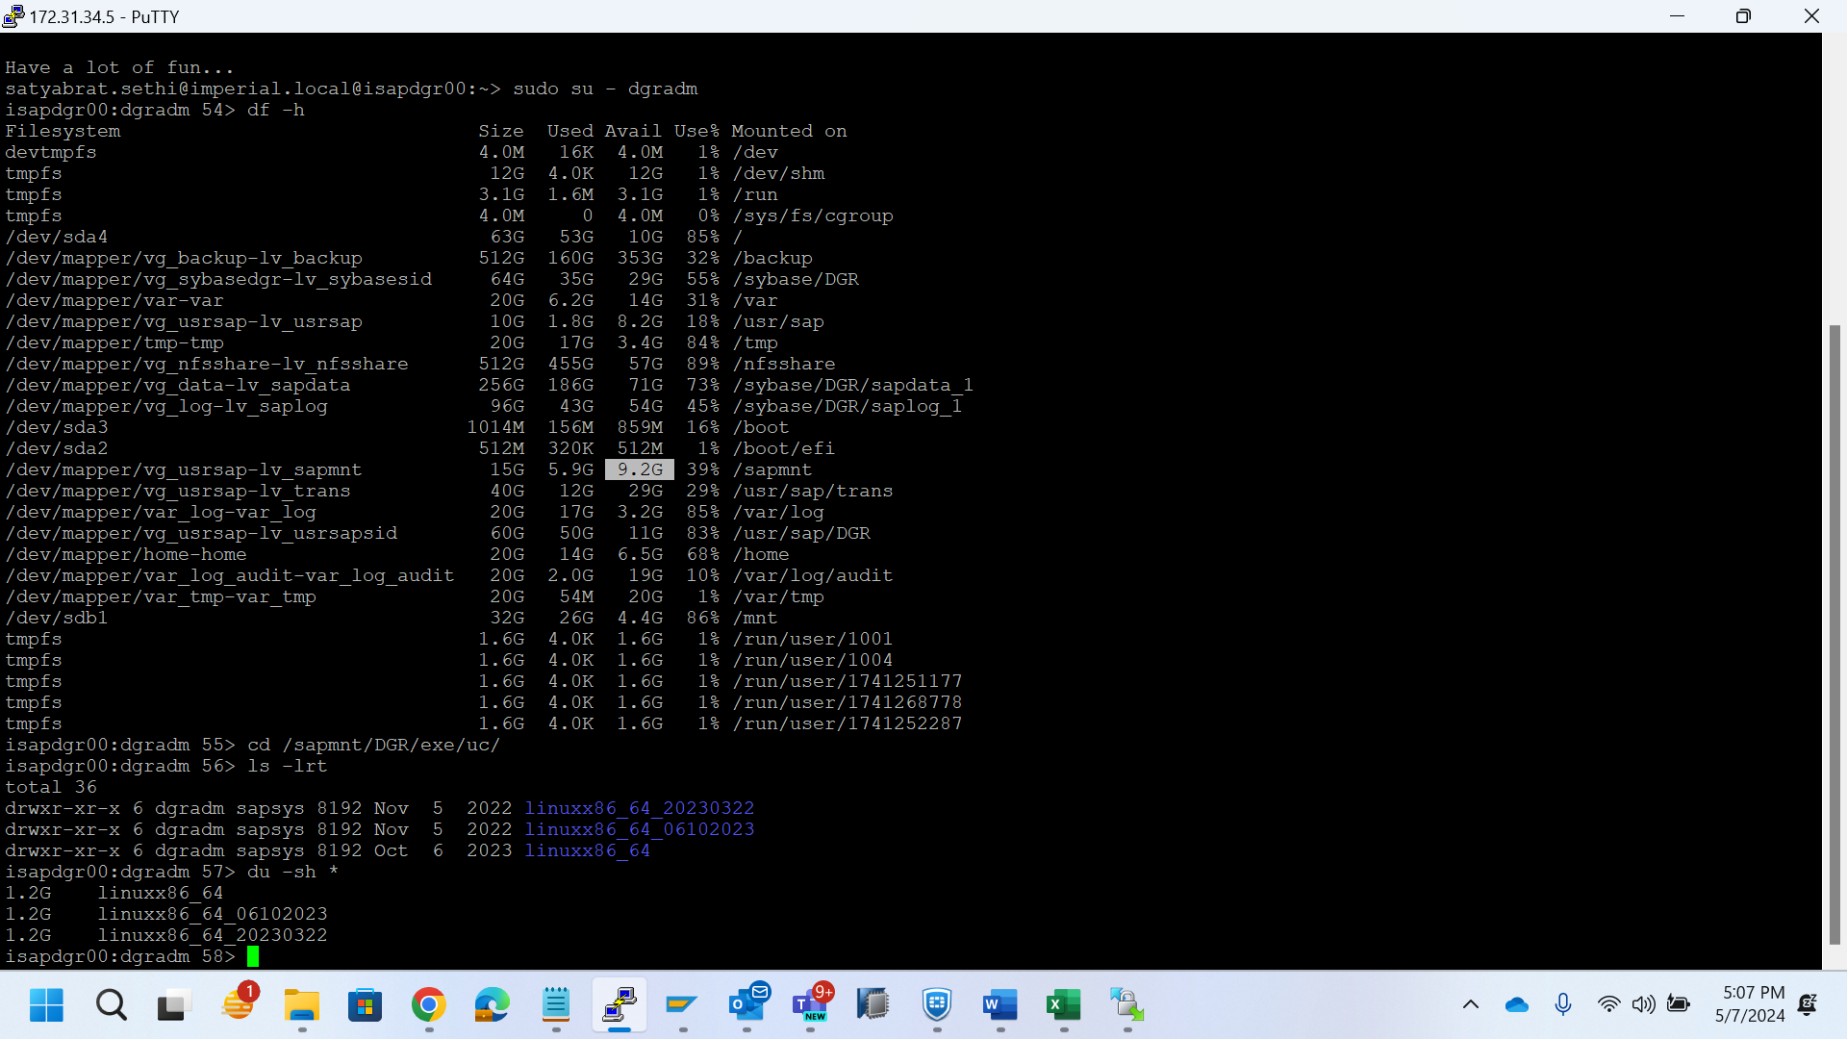

Cd/sapmnt/DGR/exe/uc/ - to see kernel file

Cp -rp linuxx86_64 – to copy the file

Rm -rf linuxx86_64 – to delete the file

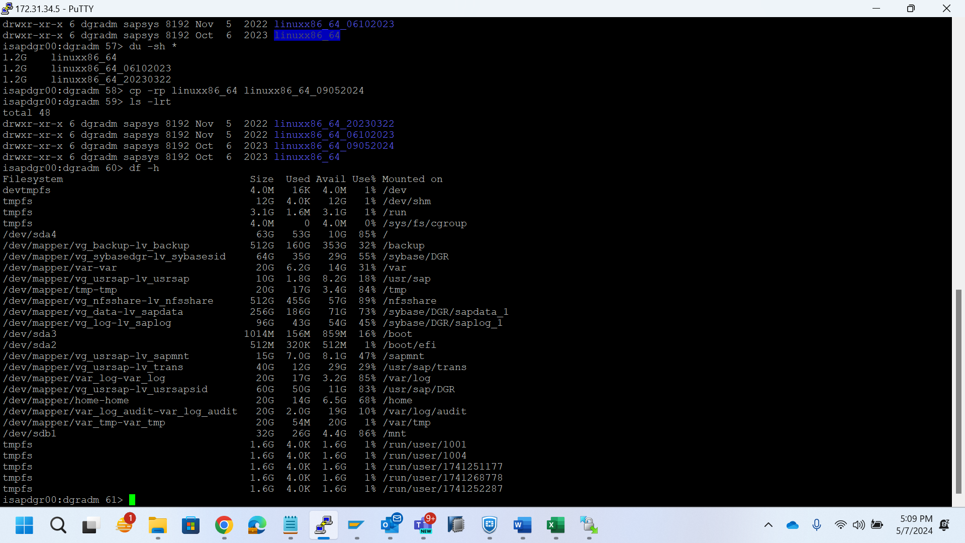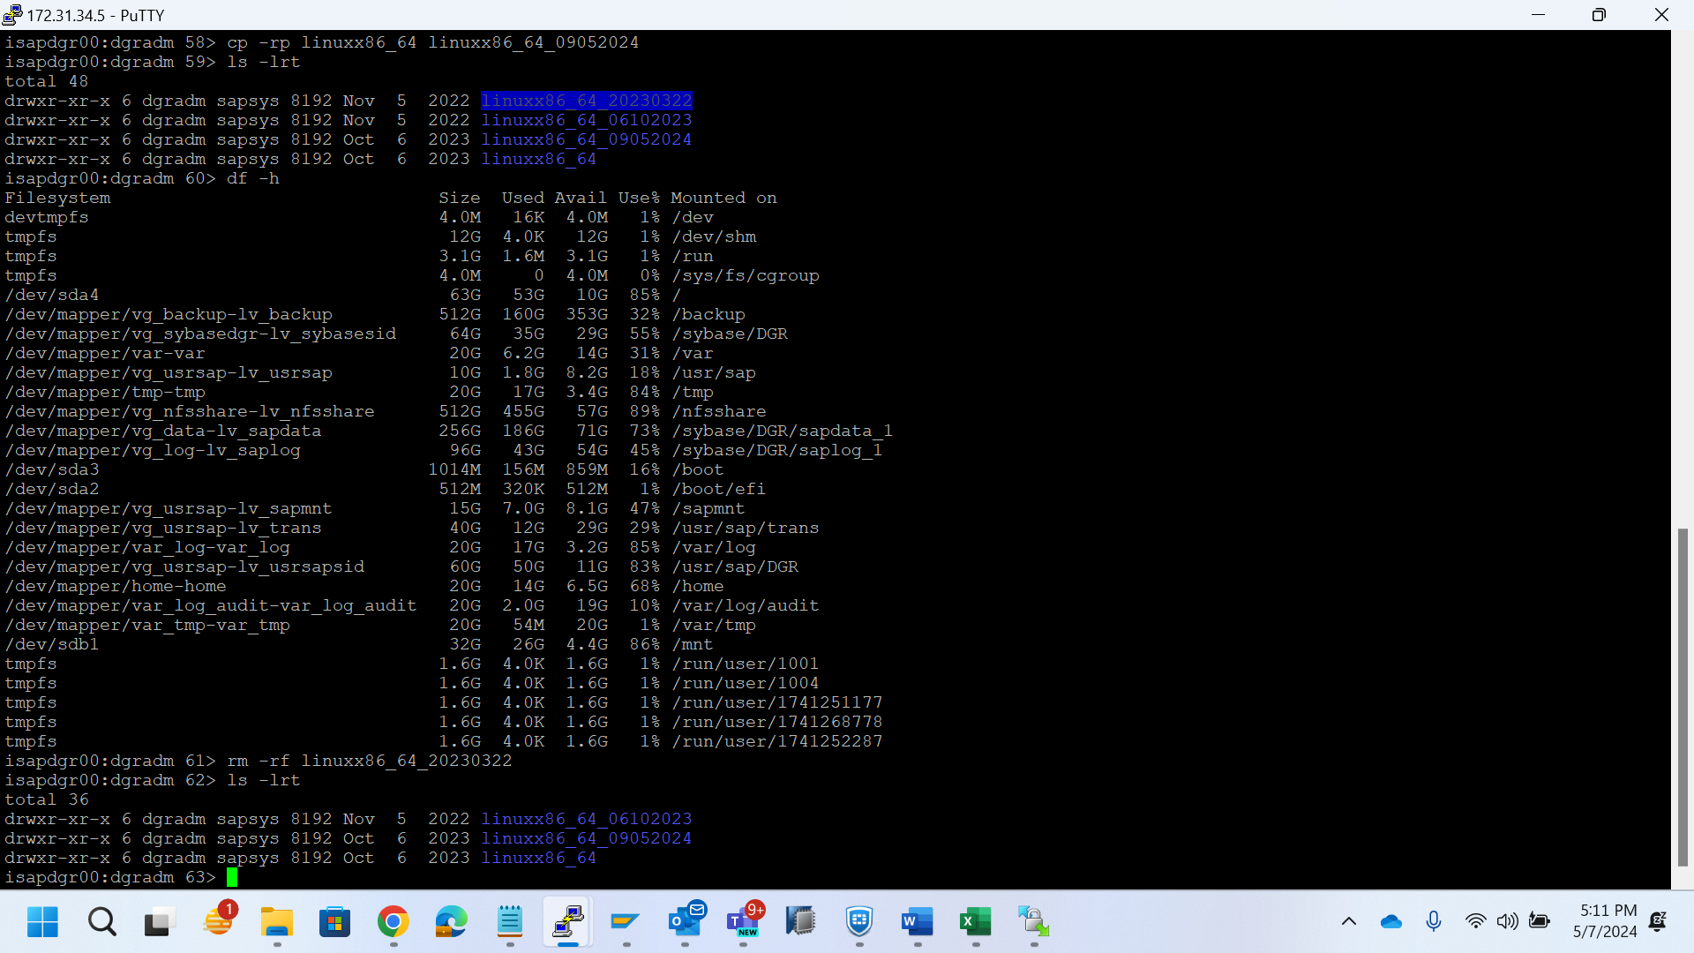

DGW-

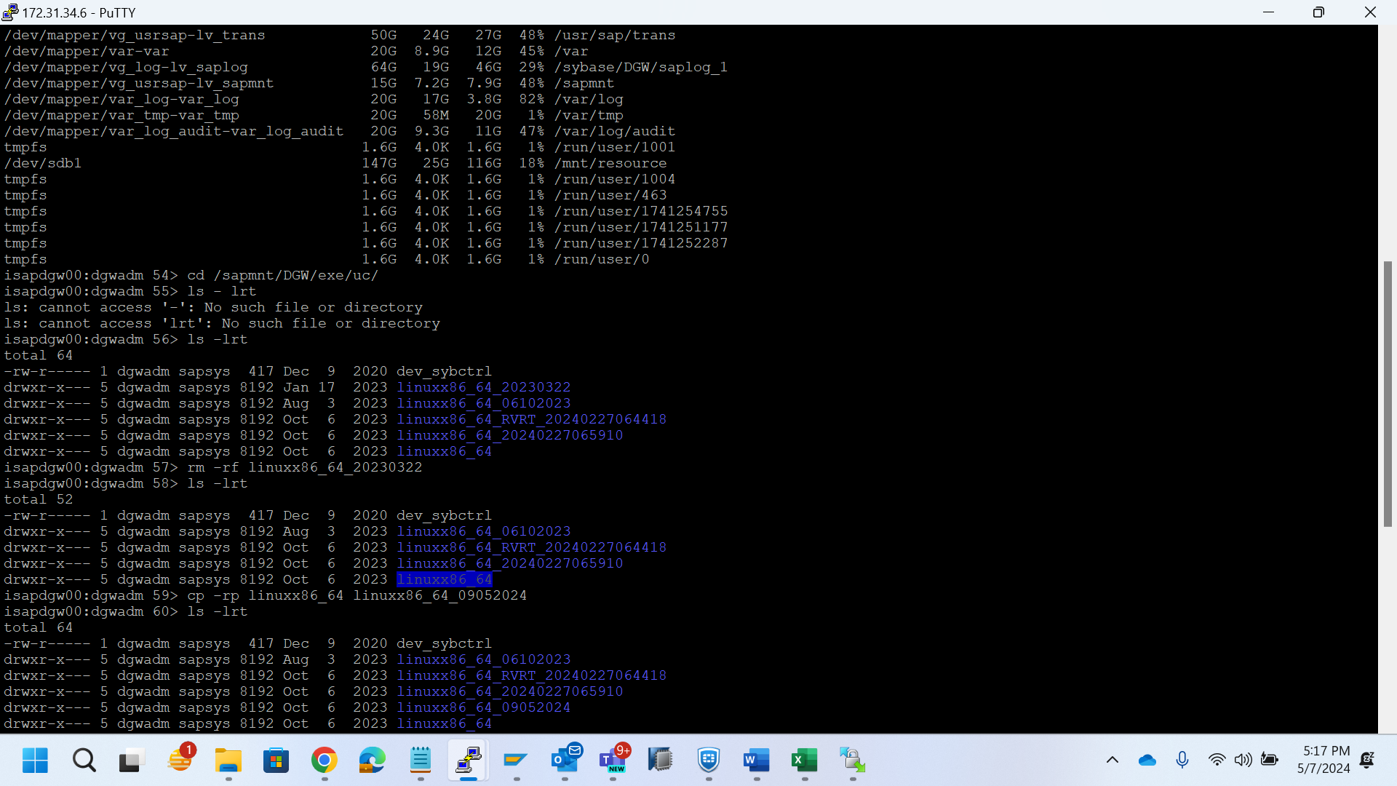

DLT –

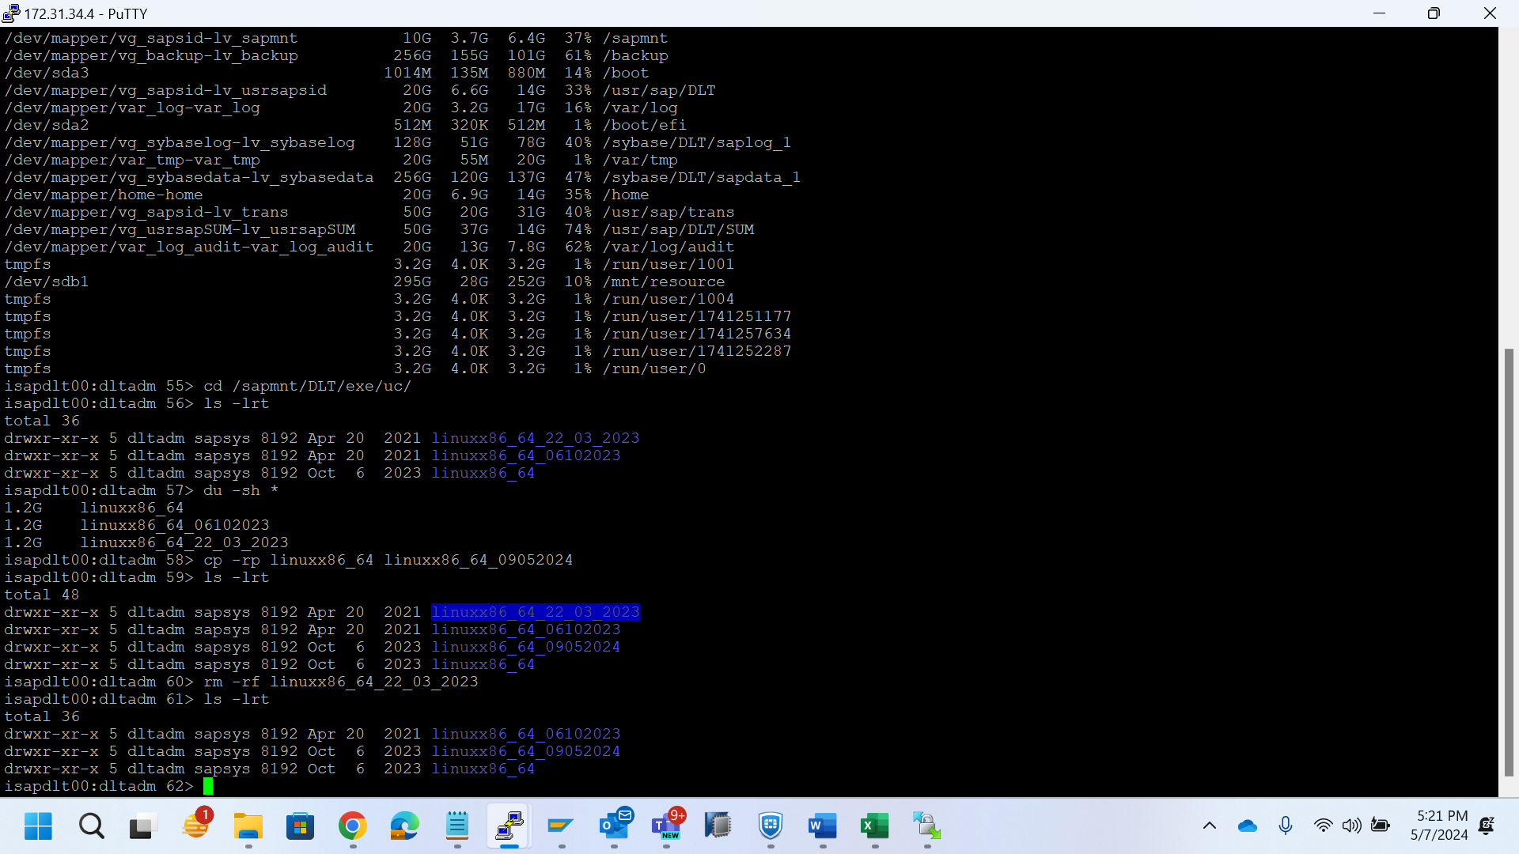

DRP –

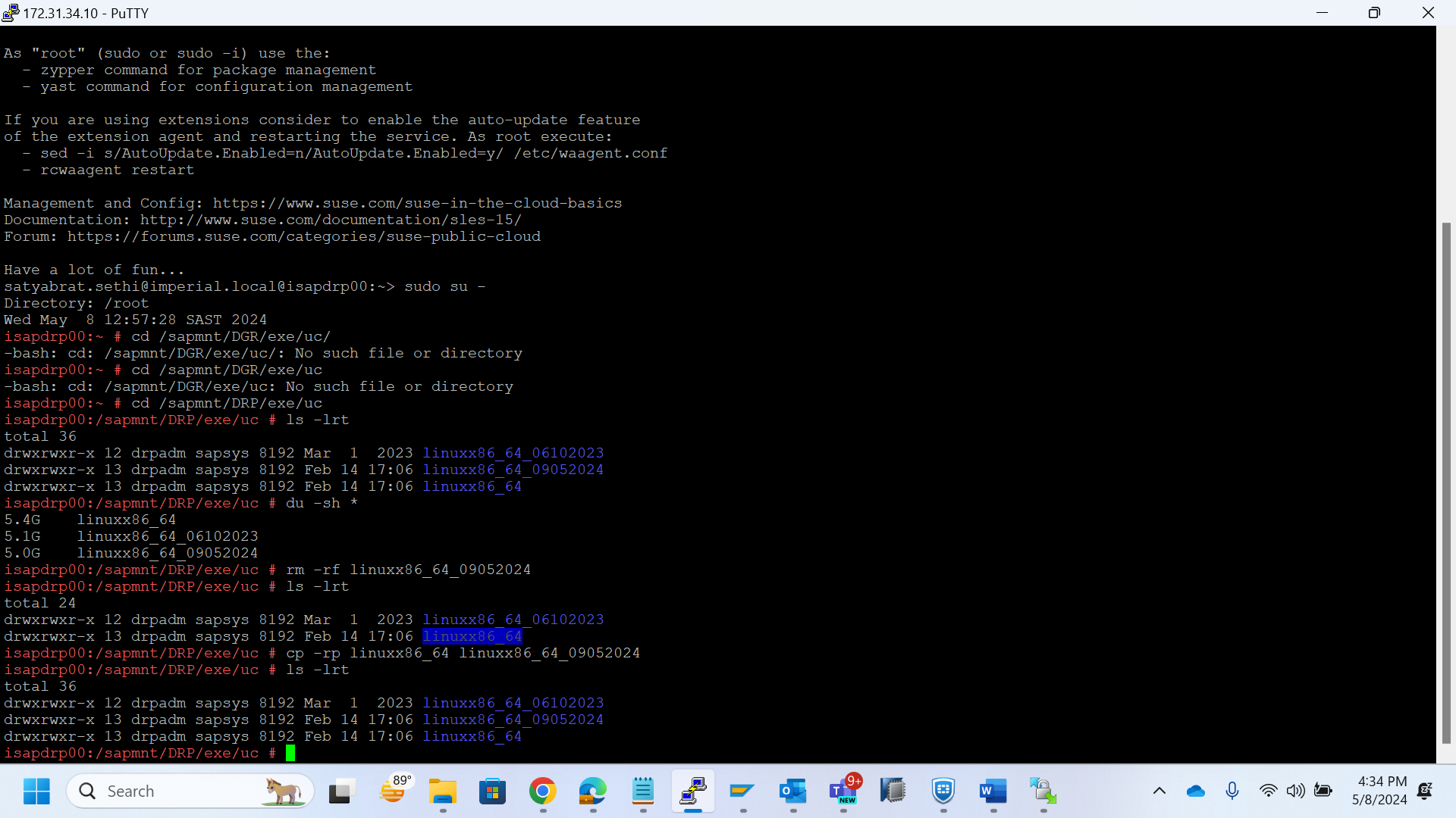

DWM –

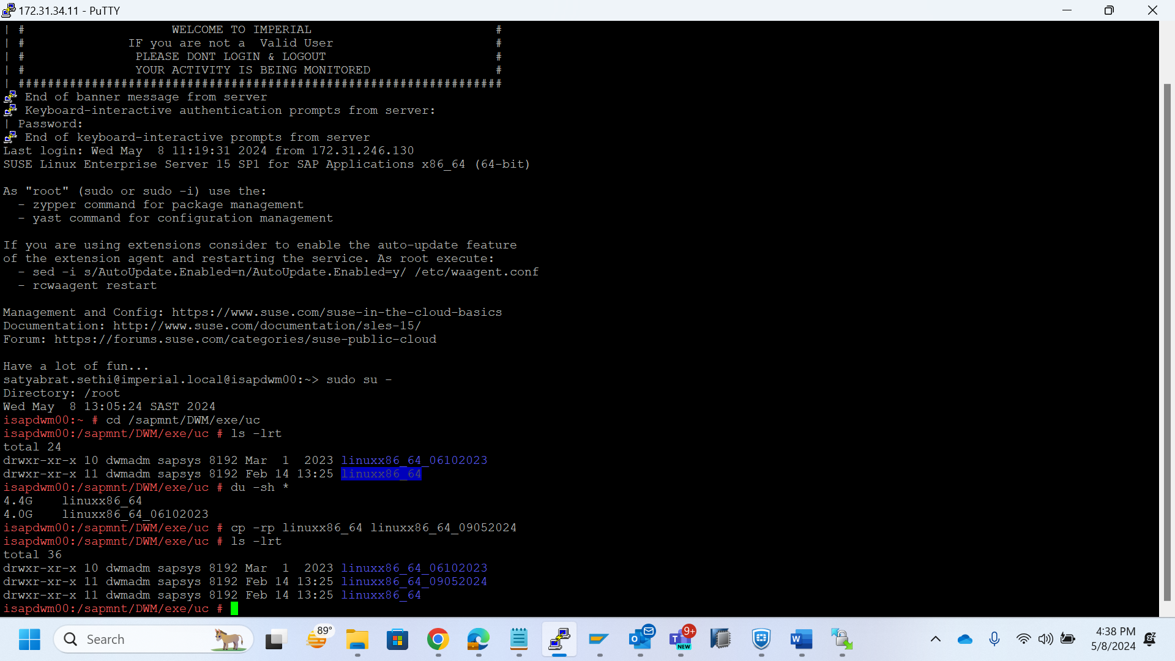

DPO –

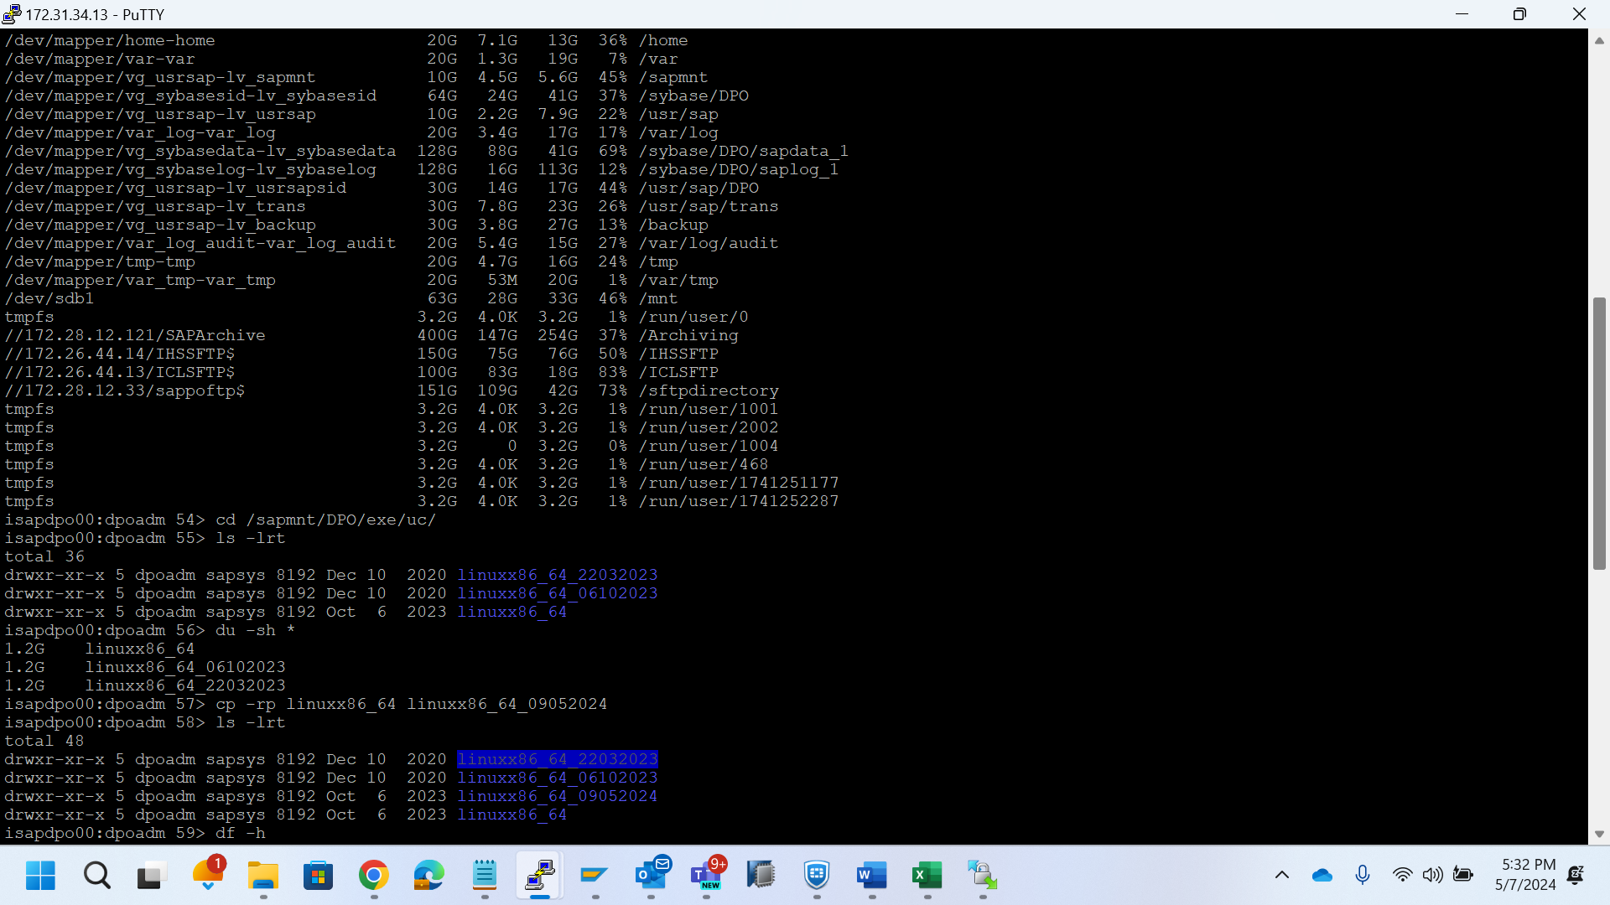

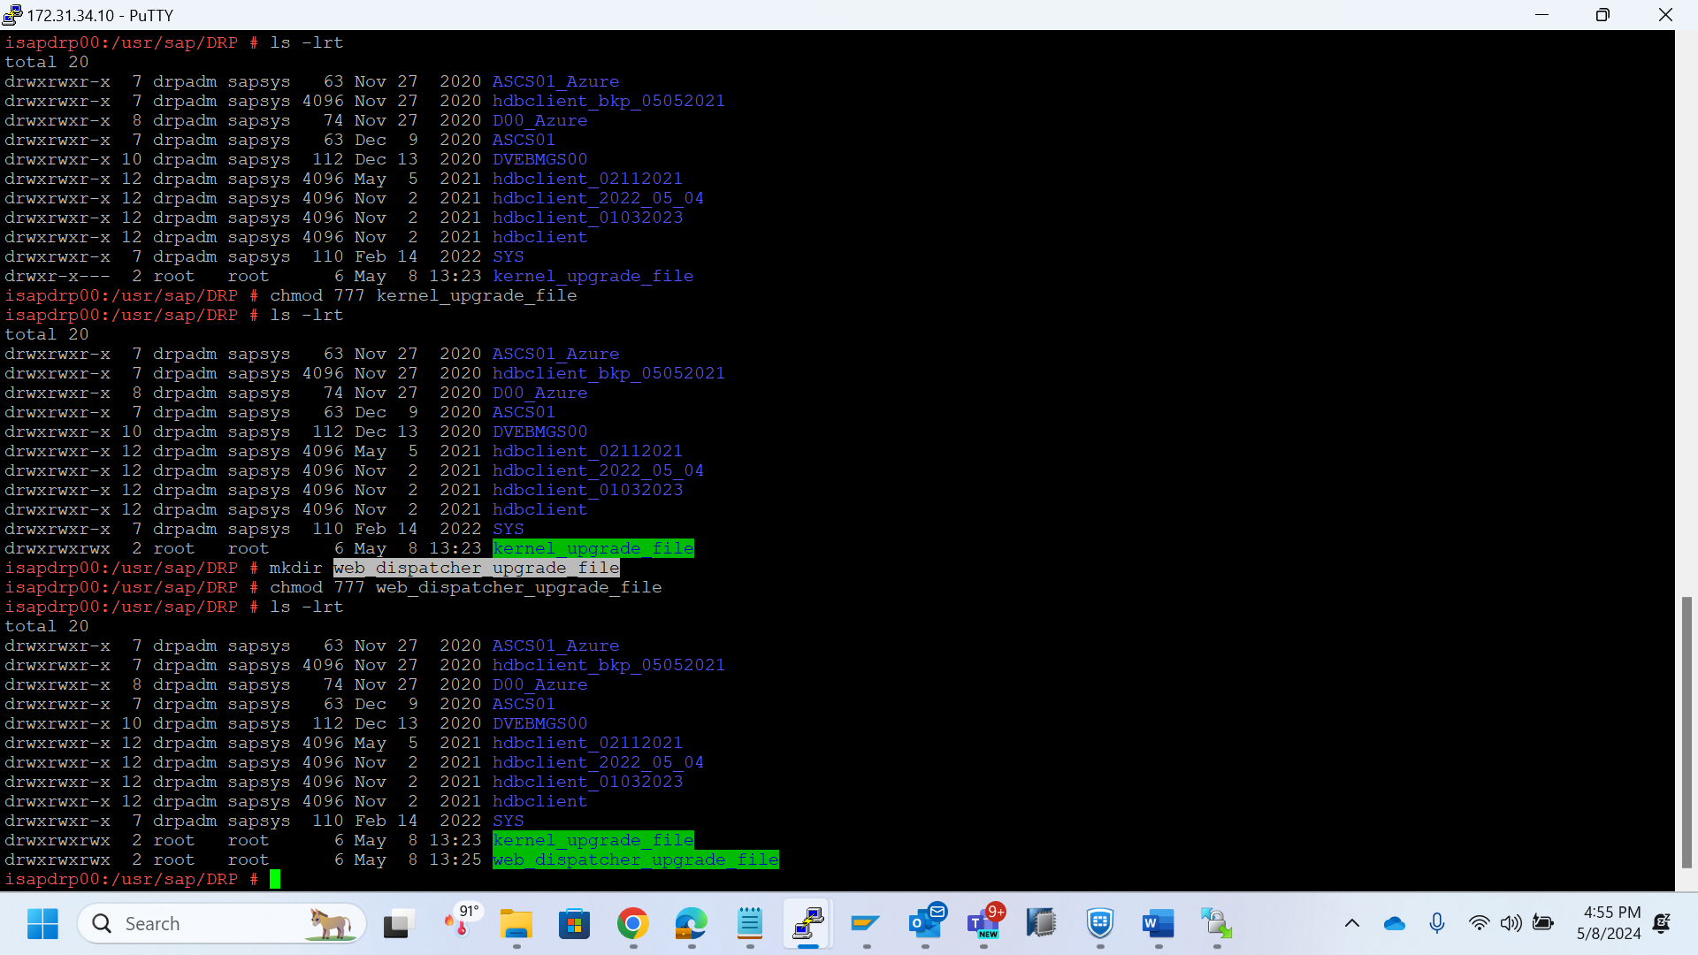

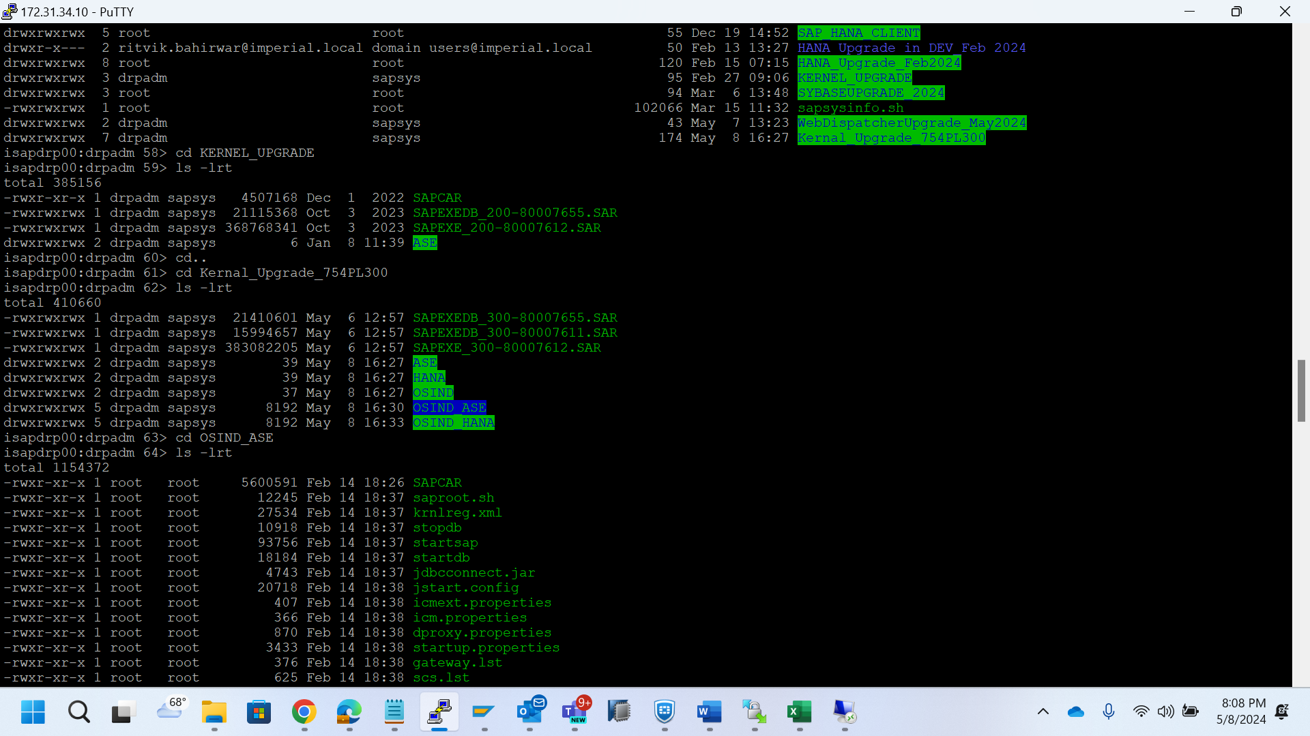

SAPCAR -xvf - extract command

Kernel upgrade -



DGR –

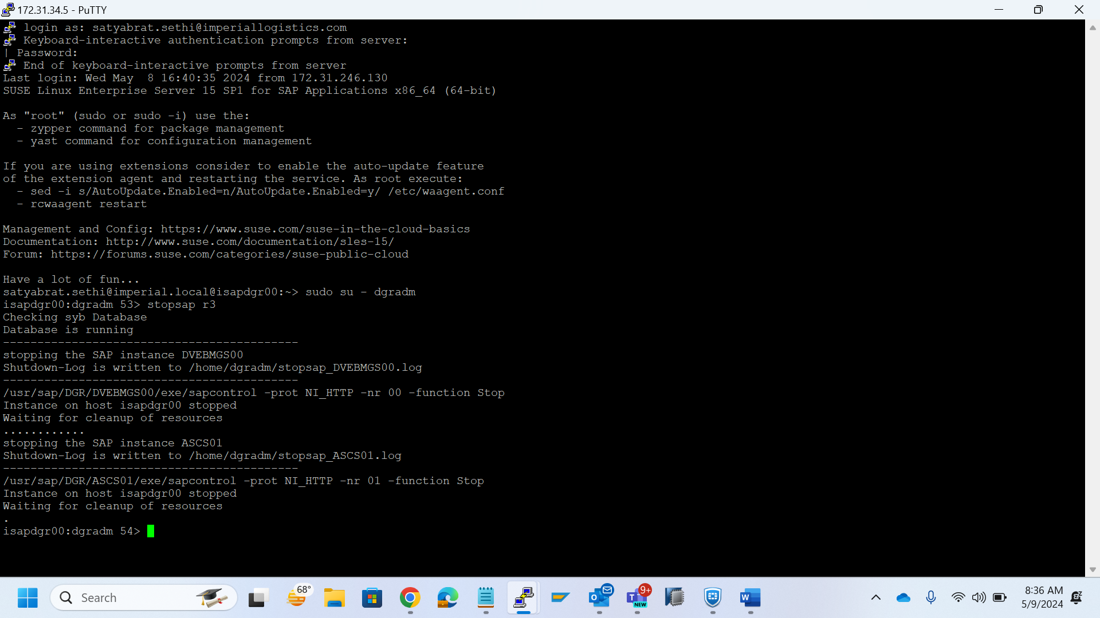

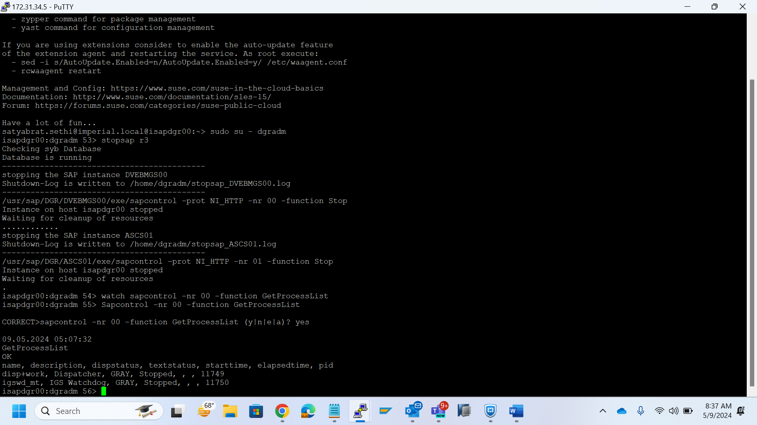

/sapmnt/DGR/exe/uc/linuxx86_64/ - to check previous file date.

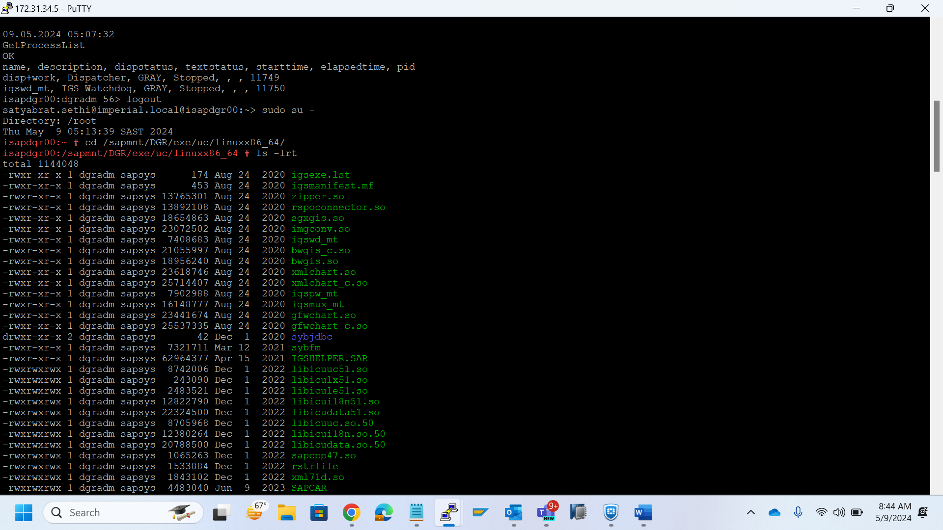

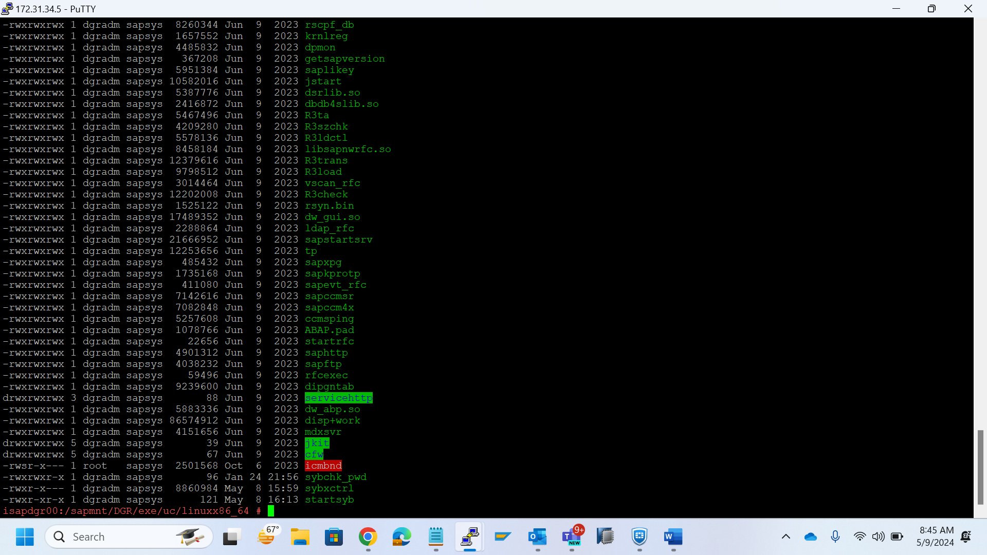

cp -rp /nfsshare/Migration/Kernal_Upgrade_754PL300/OSIND_ASE/* /sapmnt/DGR

/exe/uc/linuxx86_64/

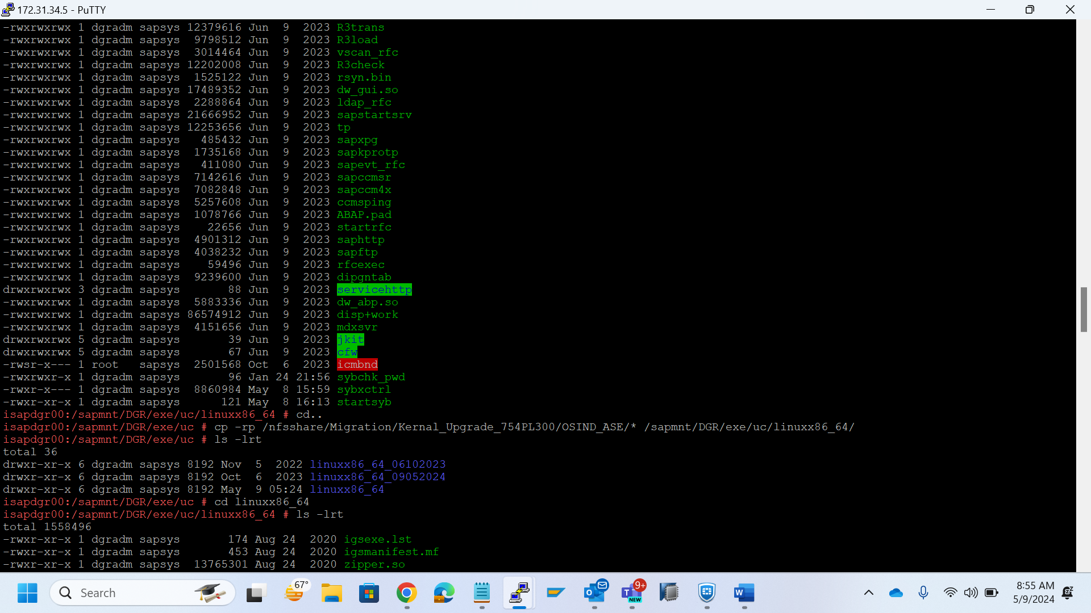

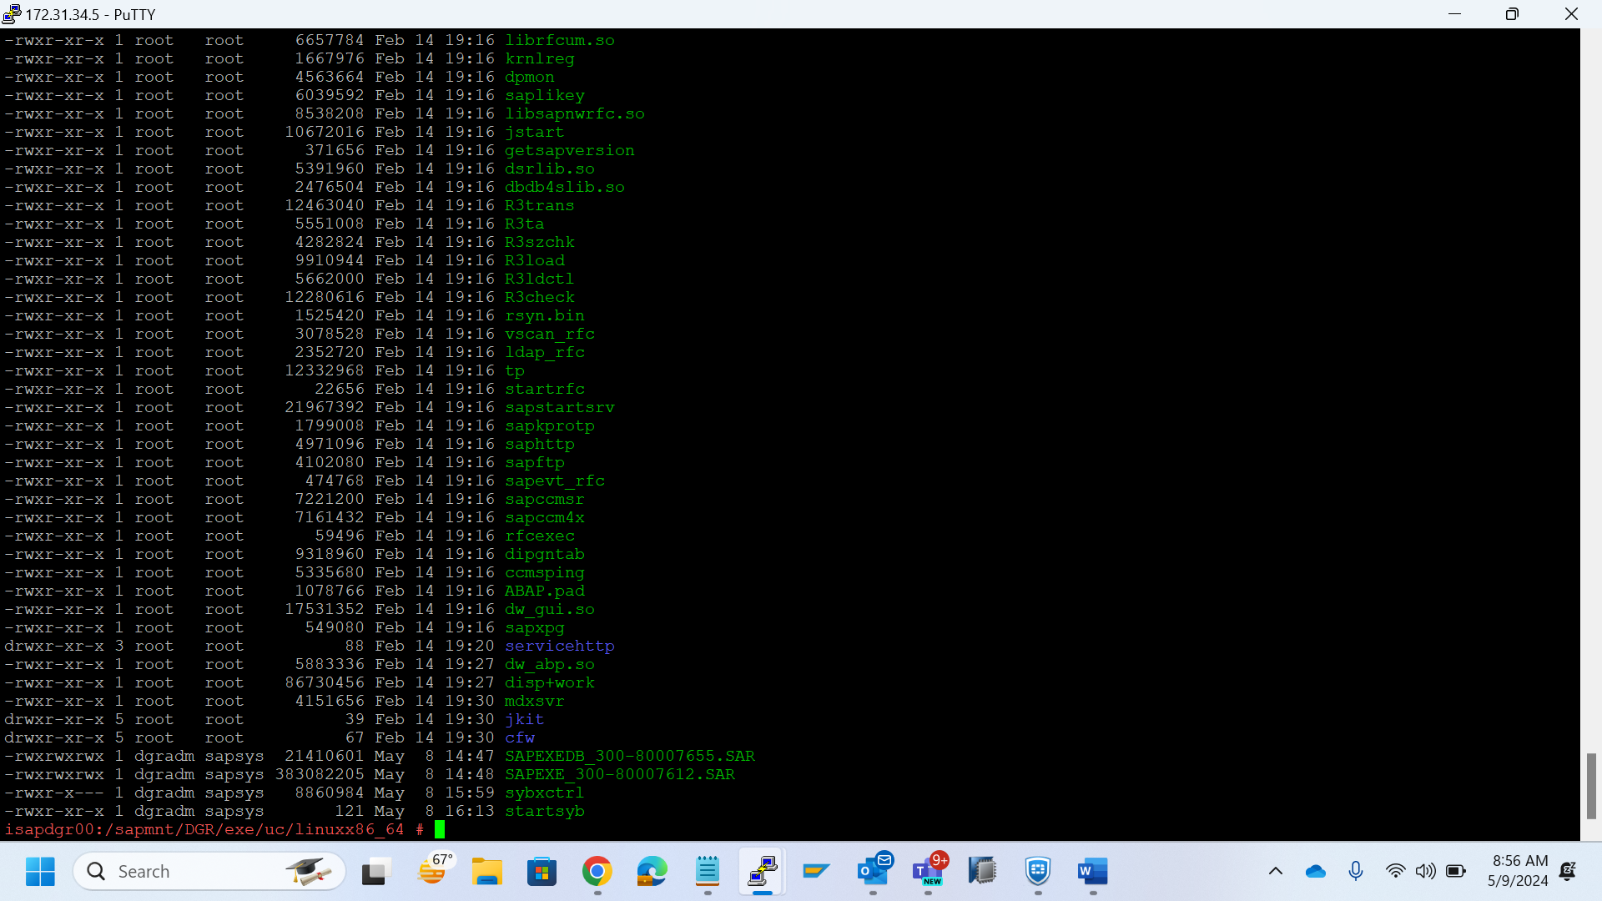

chown dgradm:sapsys *

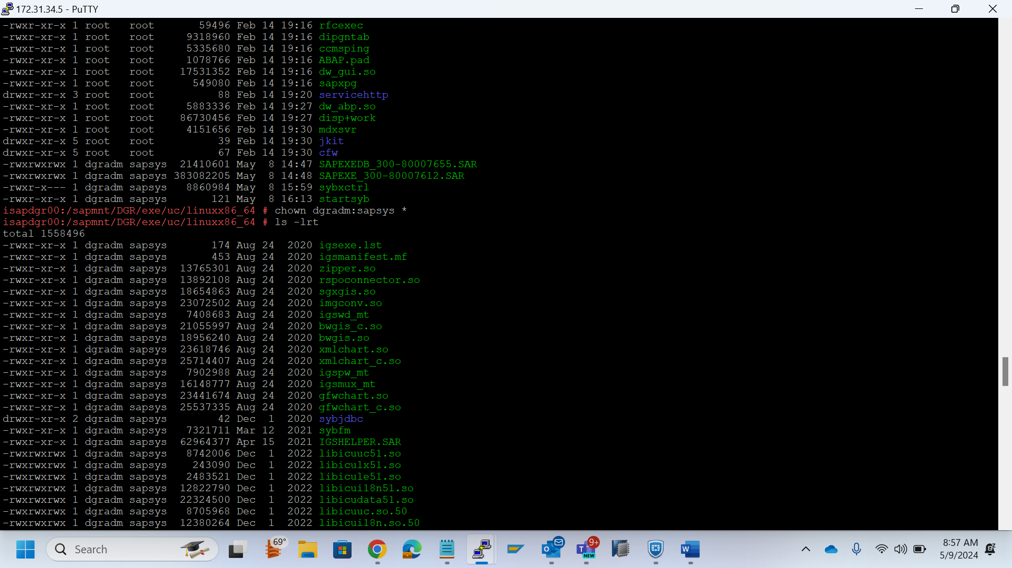

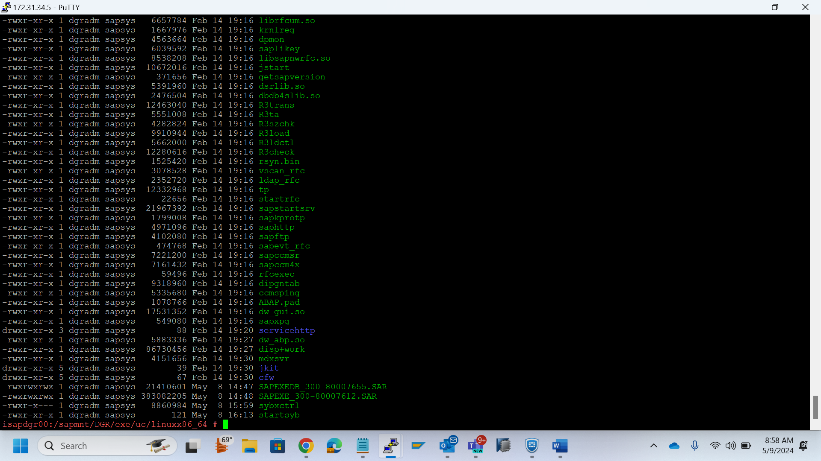

./saproot.sh DGR

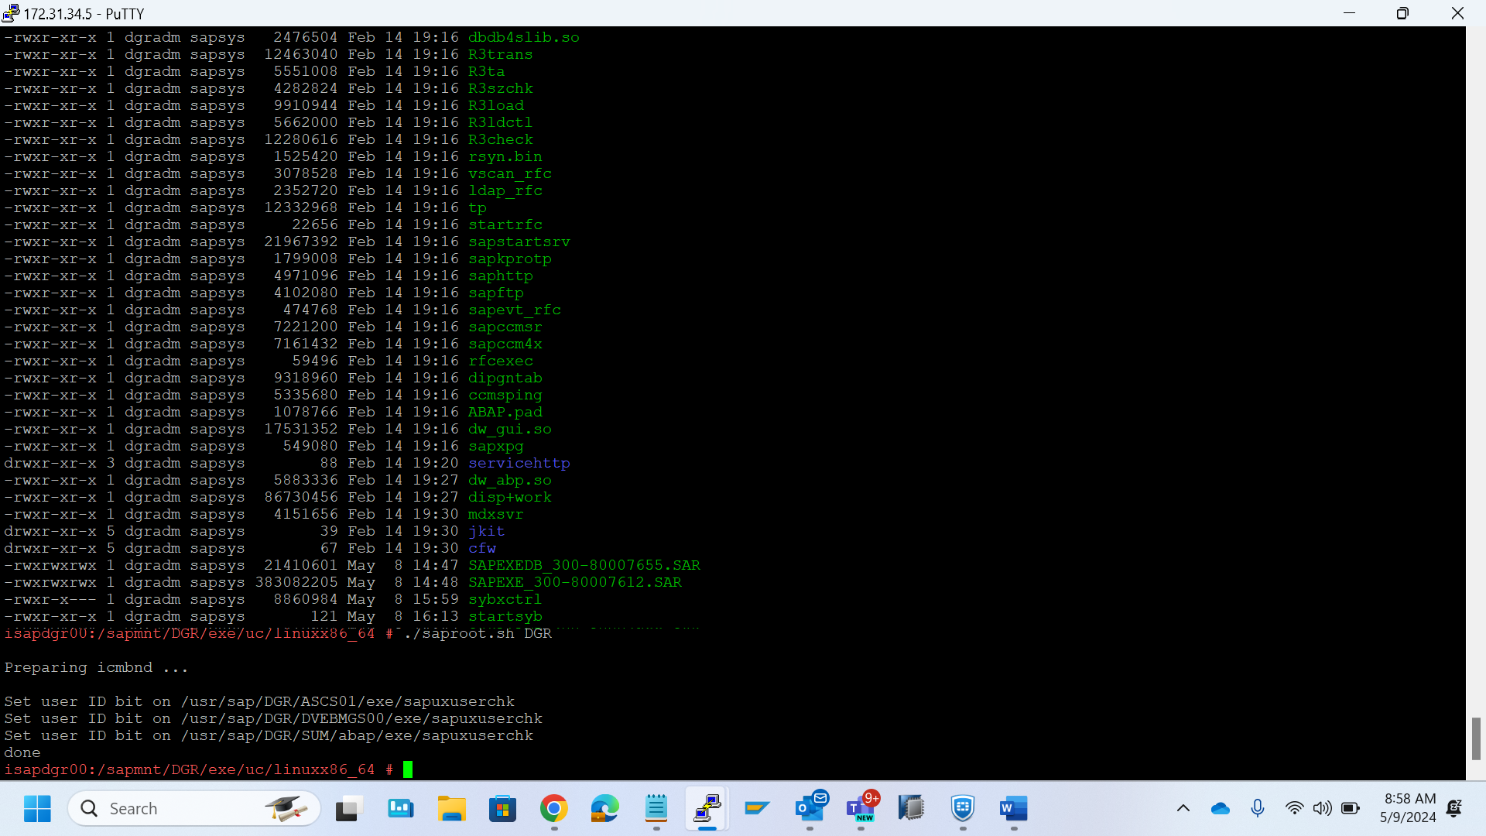

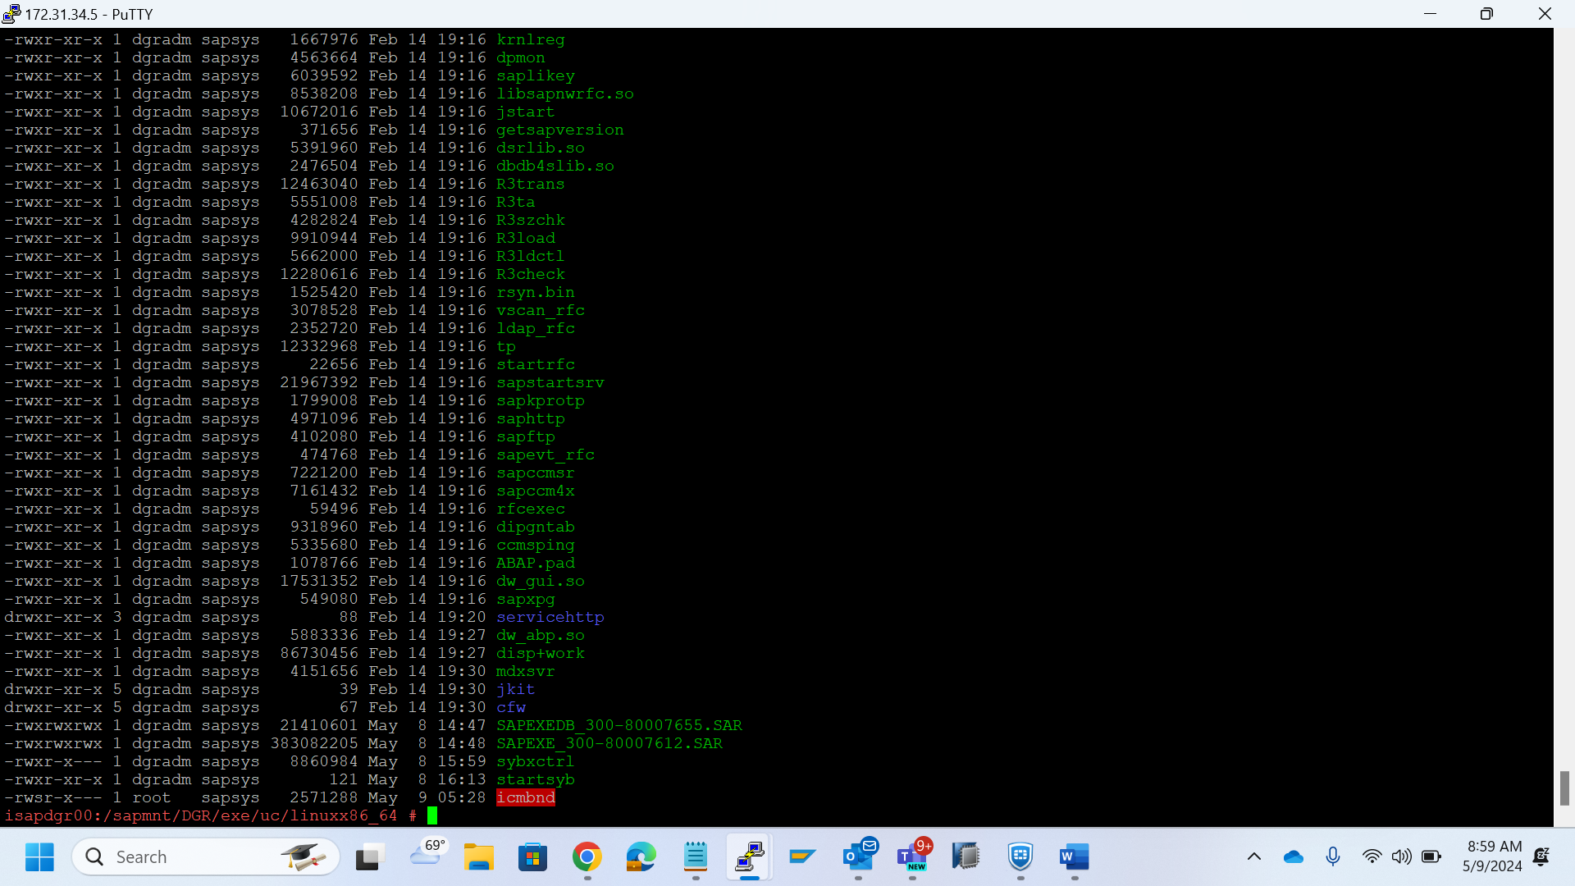

/usr/sap/DGR/SYS/exe/uc/linuxx86_64

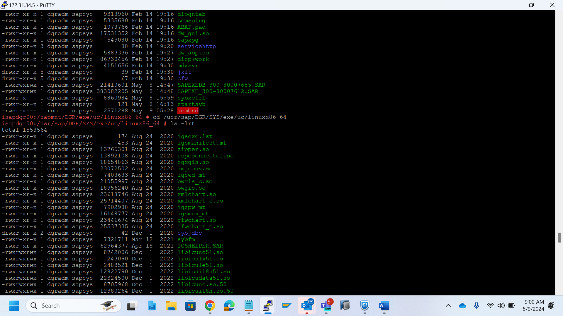

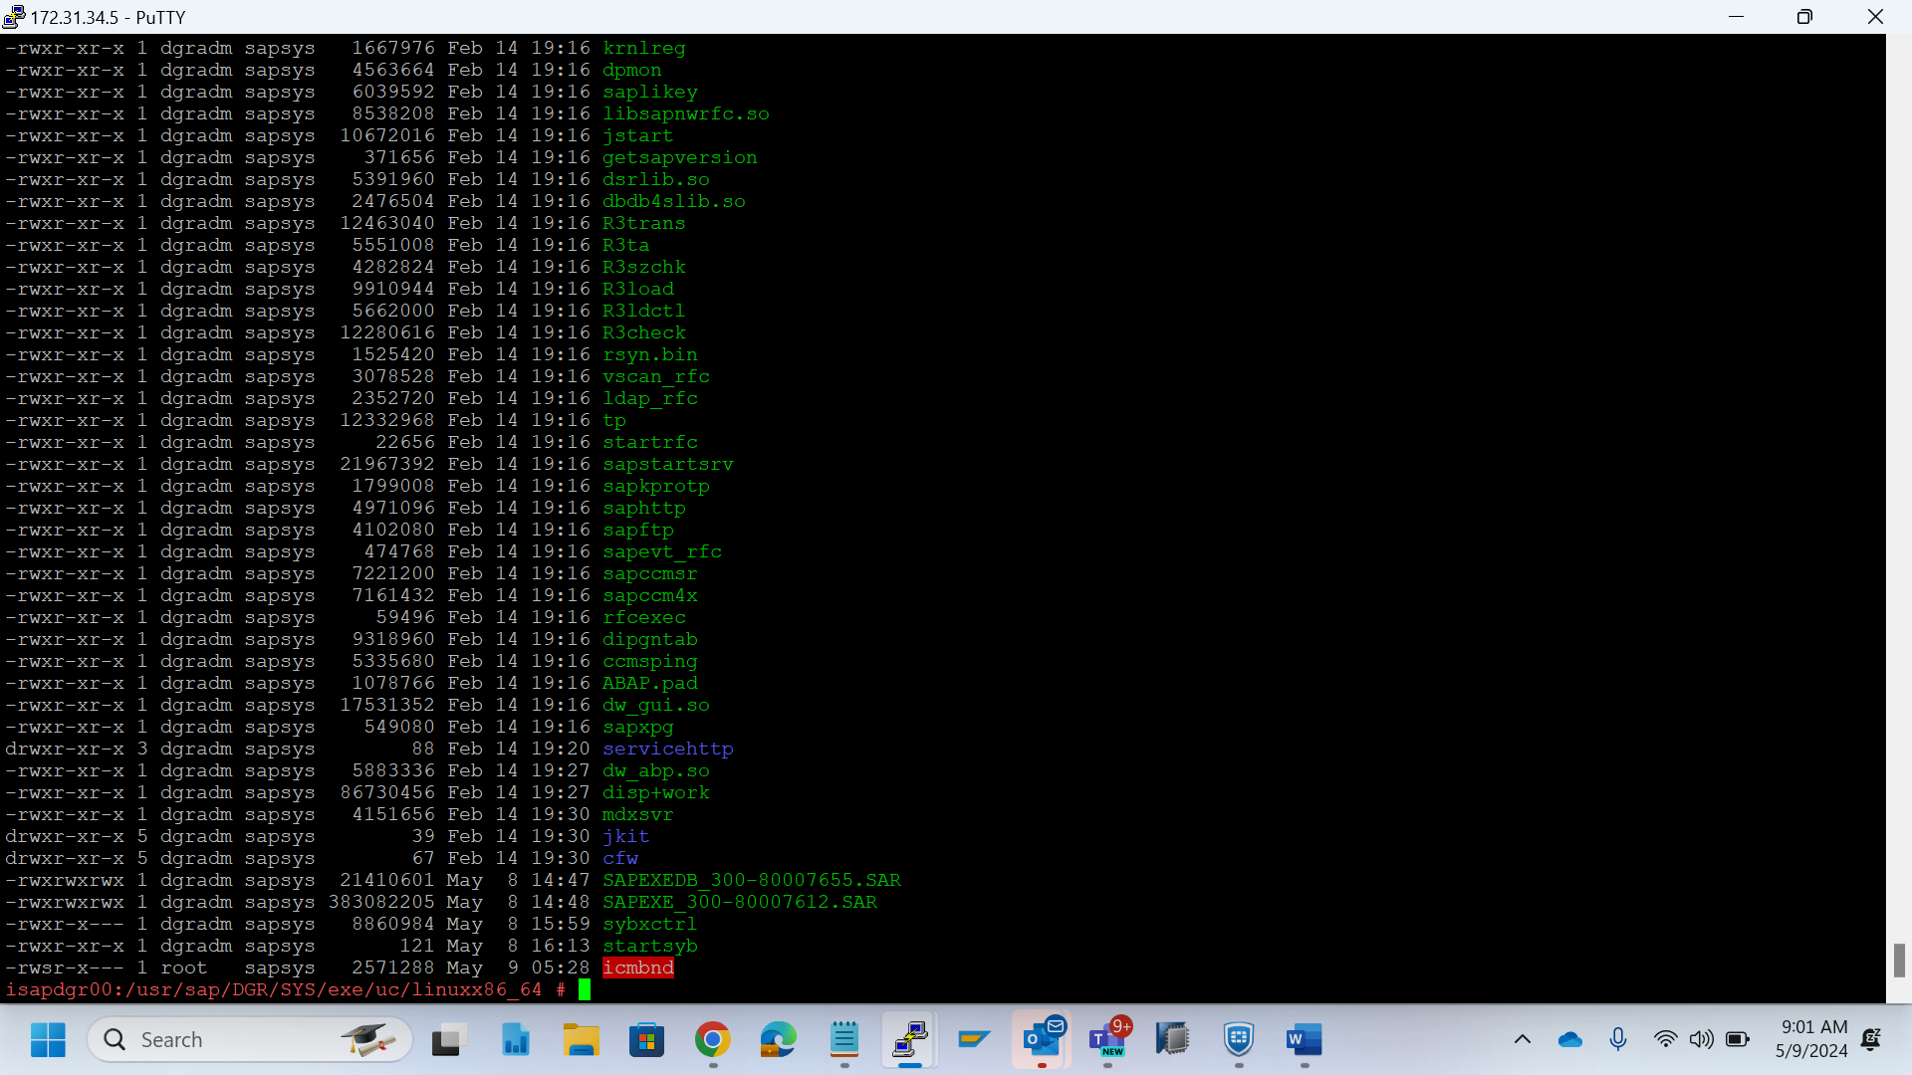

Disp+work

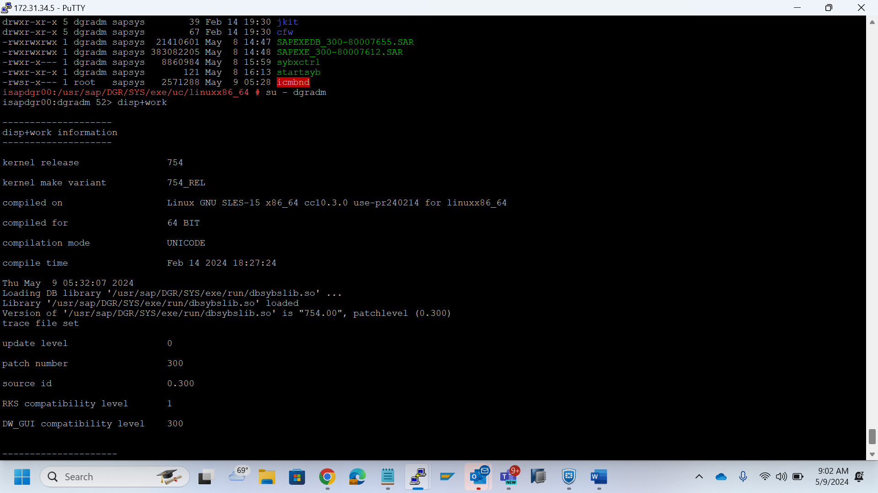

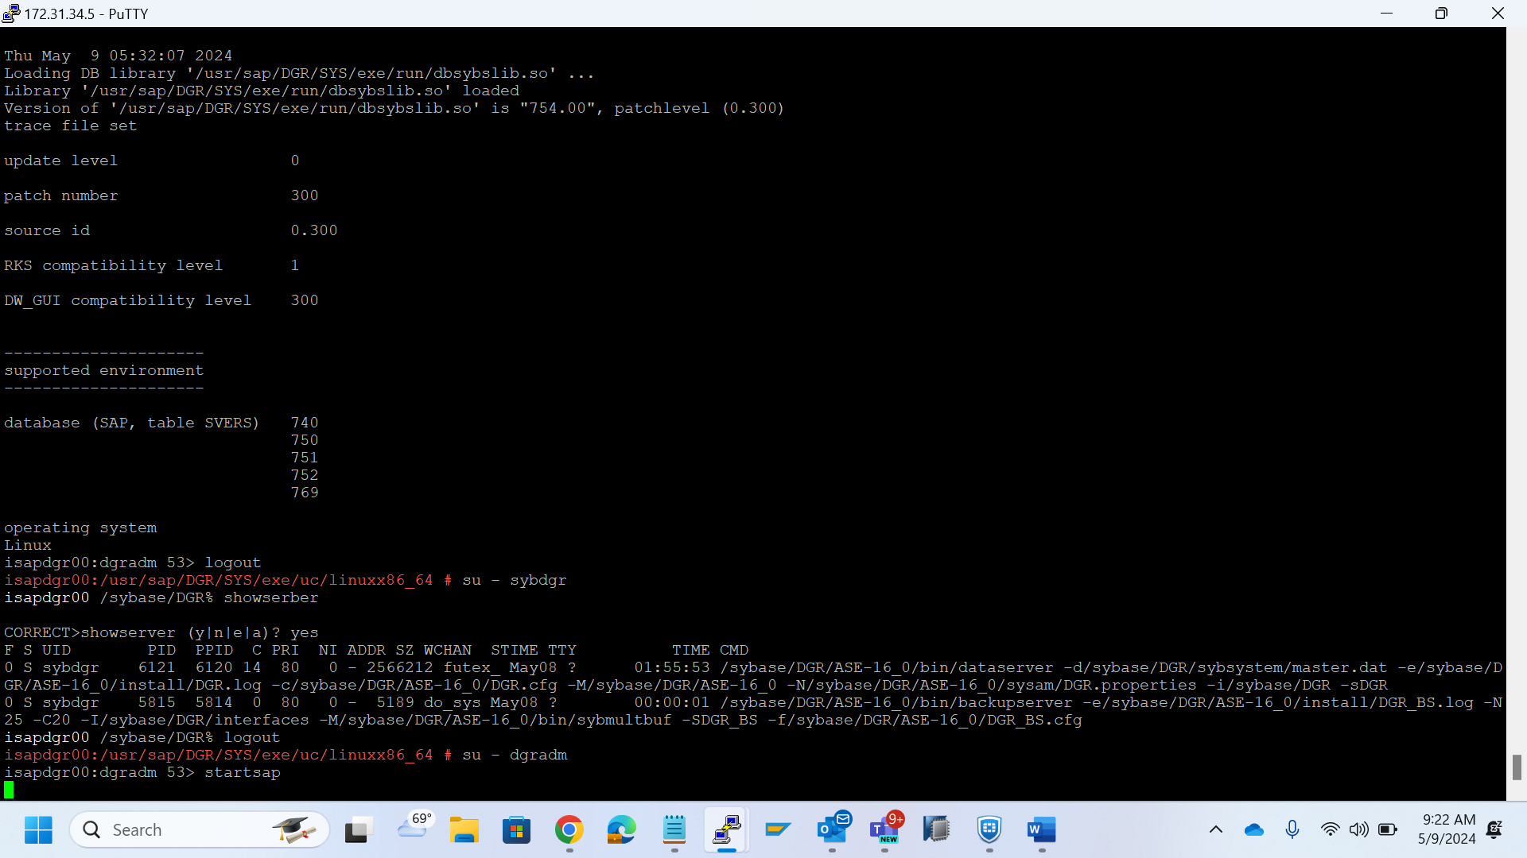

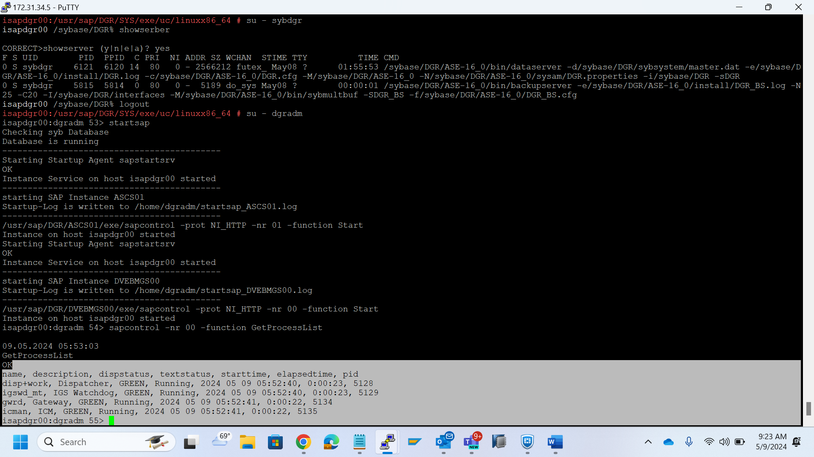

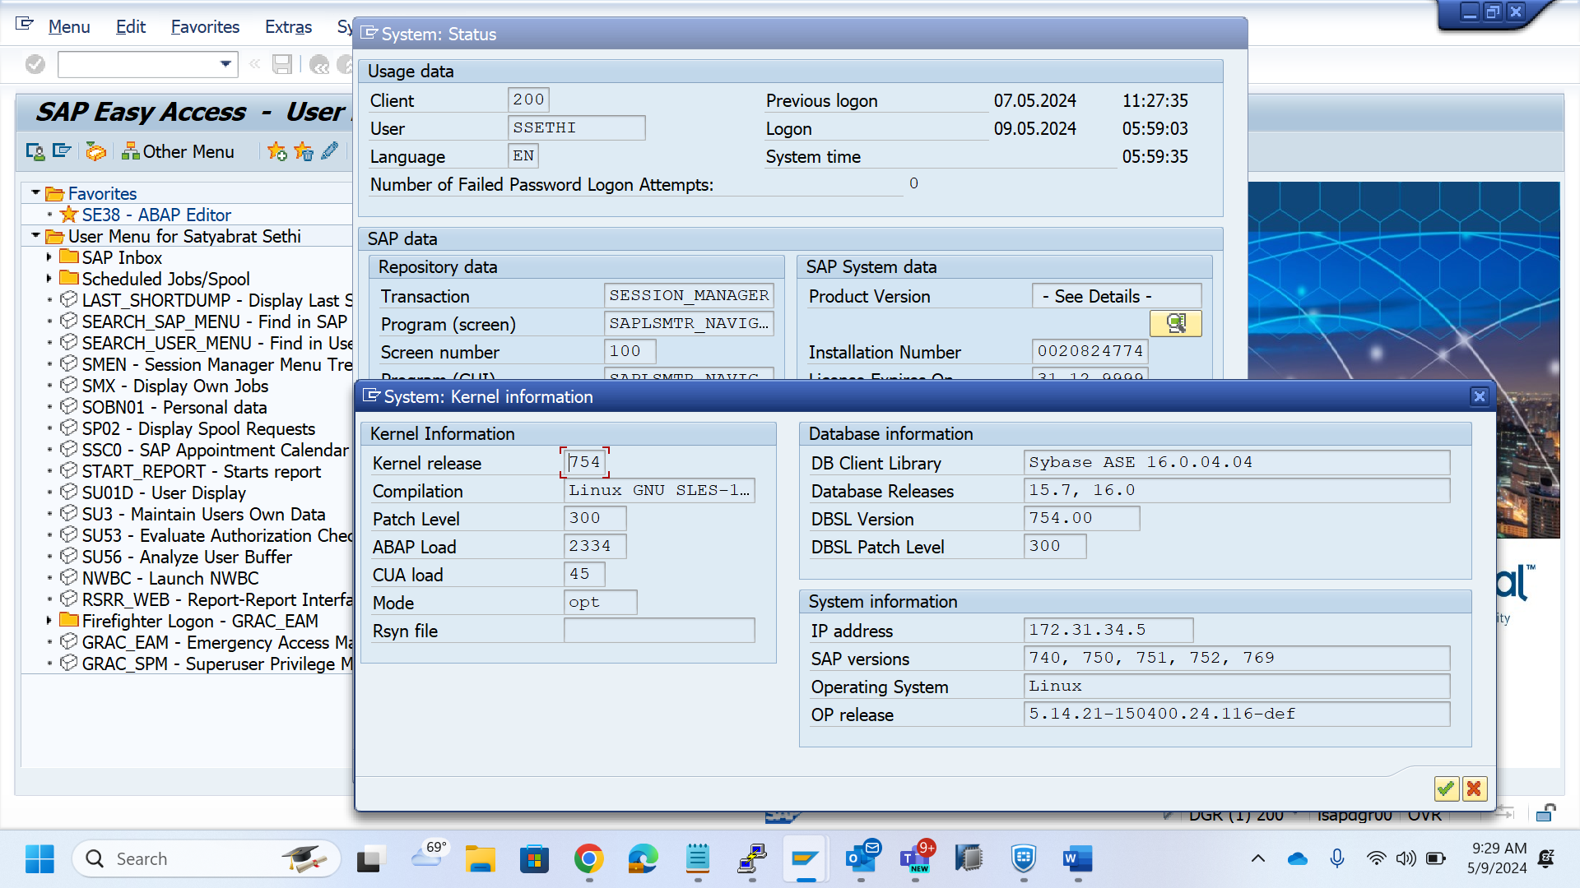

HANA system –



cp -rp /nfsshare/Migration/Kernal_Upgrade_754PL300/OSIND_HANA/* /sapmnt/DRP/exe/uc/linuxx86_64/

cp -rp /nfsshare/Migration/Kernal_Upgrade_754PL300/OSIND_HANA/* /sapmnt/DWM/exe/uc/linuxx86_64/

cp -rp /nfsshare/Migration/Kernal_Upgrade_754PL300/OSIND_ASE/* /sapmnt/DPO/exe/uc/linuxx86_64/

chown dwmadm:sapsys *

./saproot.sh DWM

/usr/sap/DWM/SYS/exe/uc/linuxx86_64

chown drpadm:sapsys *

./saproot.sh DRP

/usr/sap/DRP/SYS/exe/uc/linuxx86_64

chown dpoadm:sapsys *

./saproot.sh DPO

/usr/sap/DPO/SYS/exe/uc/linuxx86_64

DWD Web Dispatcher Upgrade



cp -rp /nfsshare/Migration/WebDispatcherUpgrade_May2024/* /sapmnt/DWD/exe/uc/linuxx86_64/  
chown dwdadm:sapsys *  
chmod 4750 icmbnd  
/usr/sap/DWD/SYS/exe/uc/linuxx86_64